IMPLEMENTING RAZOR PAGES WITH PAGE MODELS

1. Introduction
This project demonstrates the implementation of a Razor Pages application using ASP.NET Core. The application showcases Razor syntax usage, PageModel implementation, property binding, form handling, and dynamic data display.

2. Technologies Used
• C#
• ASP.NET Core Razor Pages
• .NET 8
• Visual Studio

3. Project Structure
RazorPagesDemo
├── Models
│ └── Item.cs
├── Pages
│ ├── Index.cshtml
│ ├── Index.cshtml.cs
│ ├── AddItem.cshtml
│ └── AddItem.cshtml.cs
└── Program.cs
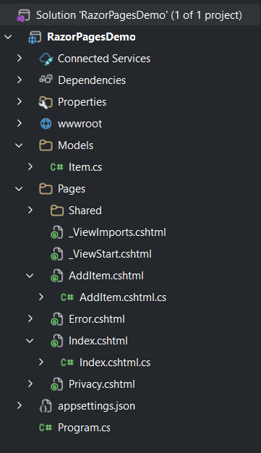

[

4. Model Implementation
The Item model represents an item in the application.
public class Item
{
public string Name { get; set; }
}
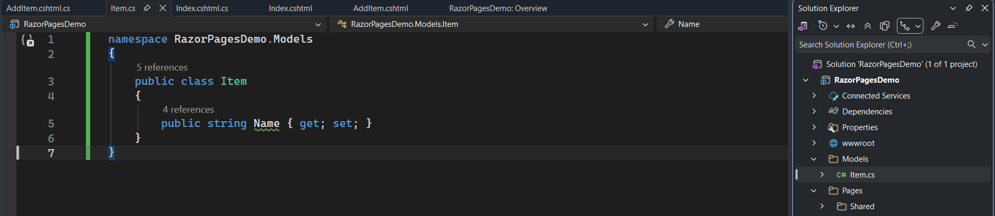

5. Razor Pages Implementation

5.1 Index Page (Display Items)
The Index page displays a list of items dynamically using Razor syntax such as @page, @model, @foreach loop, and @item.Name.
Index.cshtml: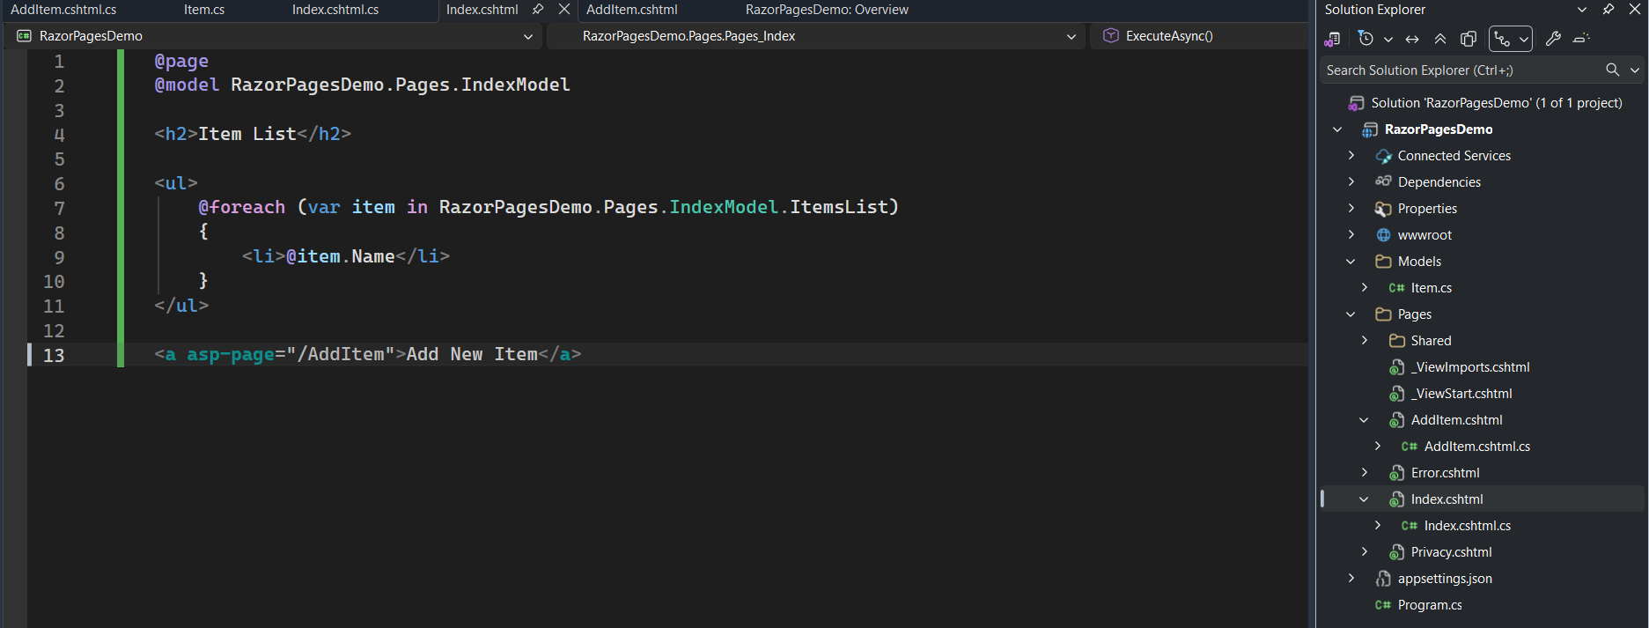
Index.cshtml.cs: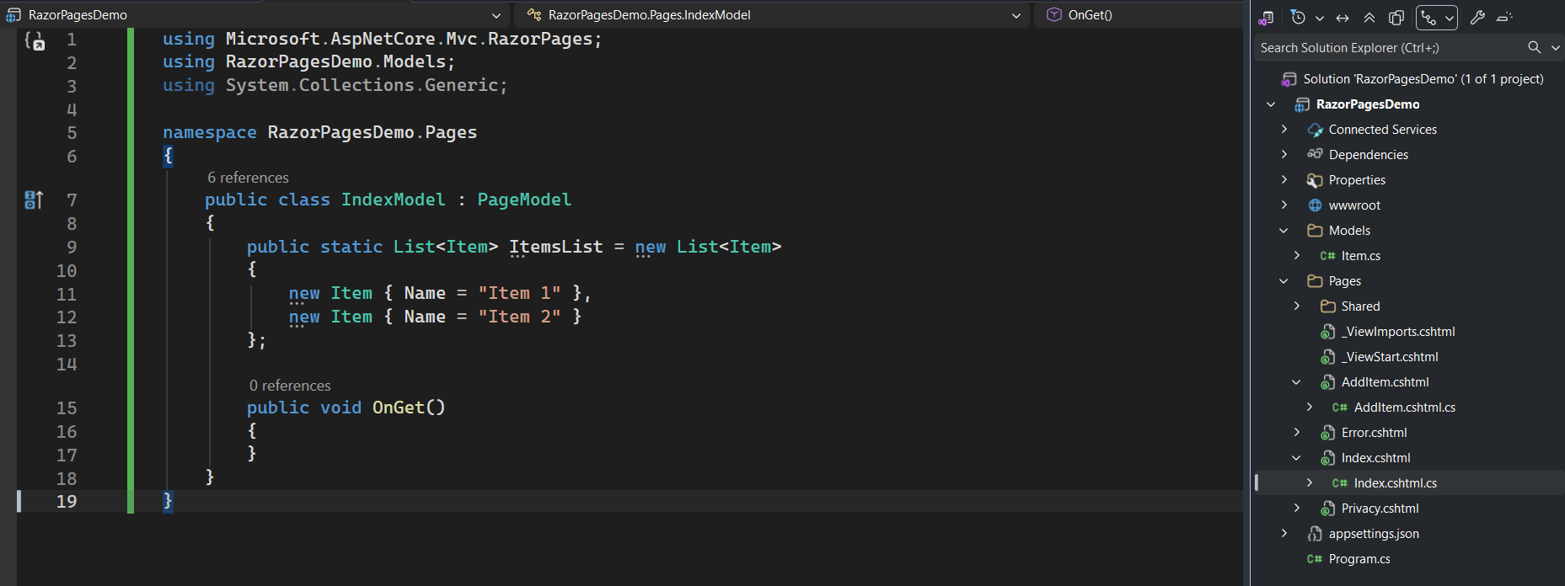

5.2 AddItem Page (Add New Item)
The AddItem page allows the user to add new items using form submission. It uses asp-for for binding and [BindProperty] for handling form data.
[BindProperty]
public Item NewItem { get; set; }
public IActionResult OnPost()
{
IndexModel.ItemsList.Add(NewItem);
return RedirectToPage("Index");
}
AddItem.cshtml: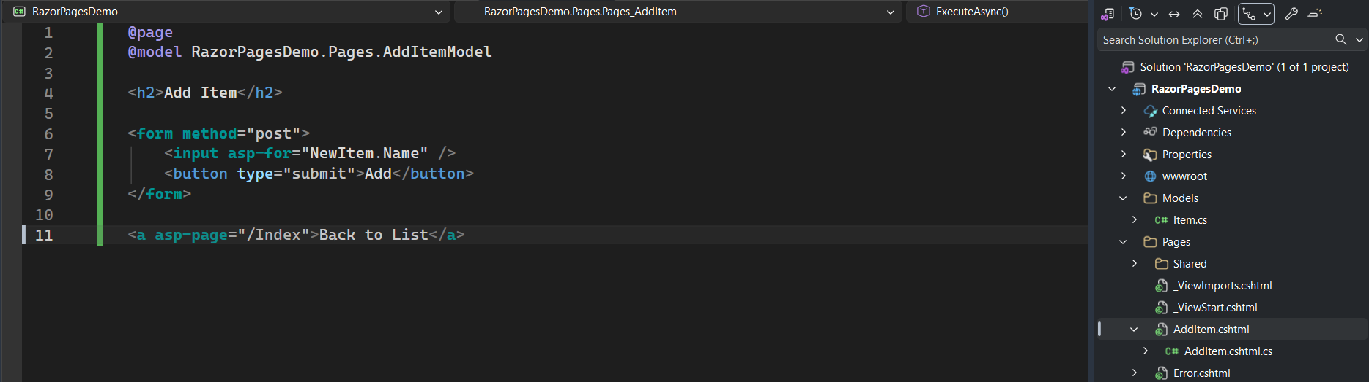
AddItem.cshtml.cs: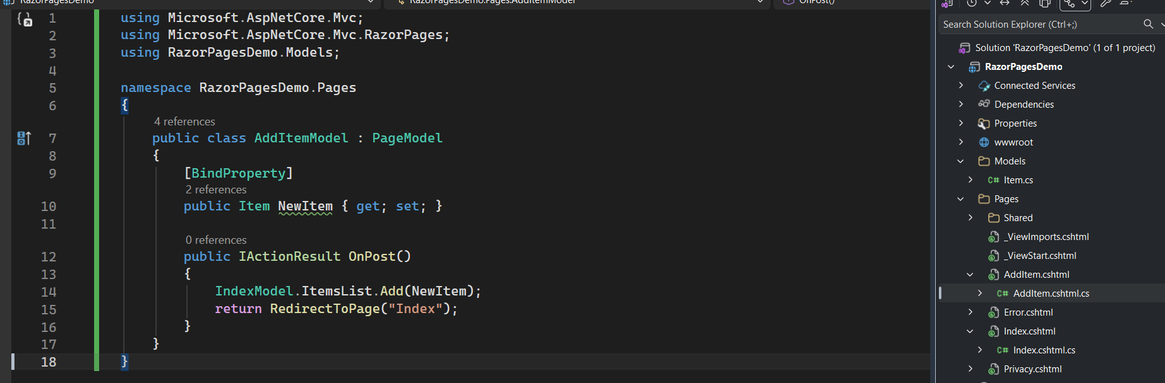

6. Razor Syntax Explanation
• @foreach – Loop through items dynamically
• @item.Name – Display dynamic data
• asp-page – Navigation between pages
• asp-for – Model binding for form inputs

7. Dynamic Data Handling
When the user adds a new item and submits the form, the OnPost() method adds the item to the list and redirects back to the Index page where the updated list is displayed.
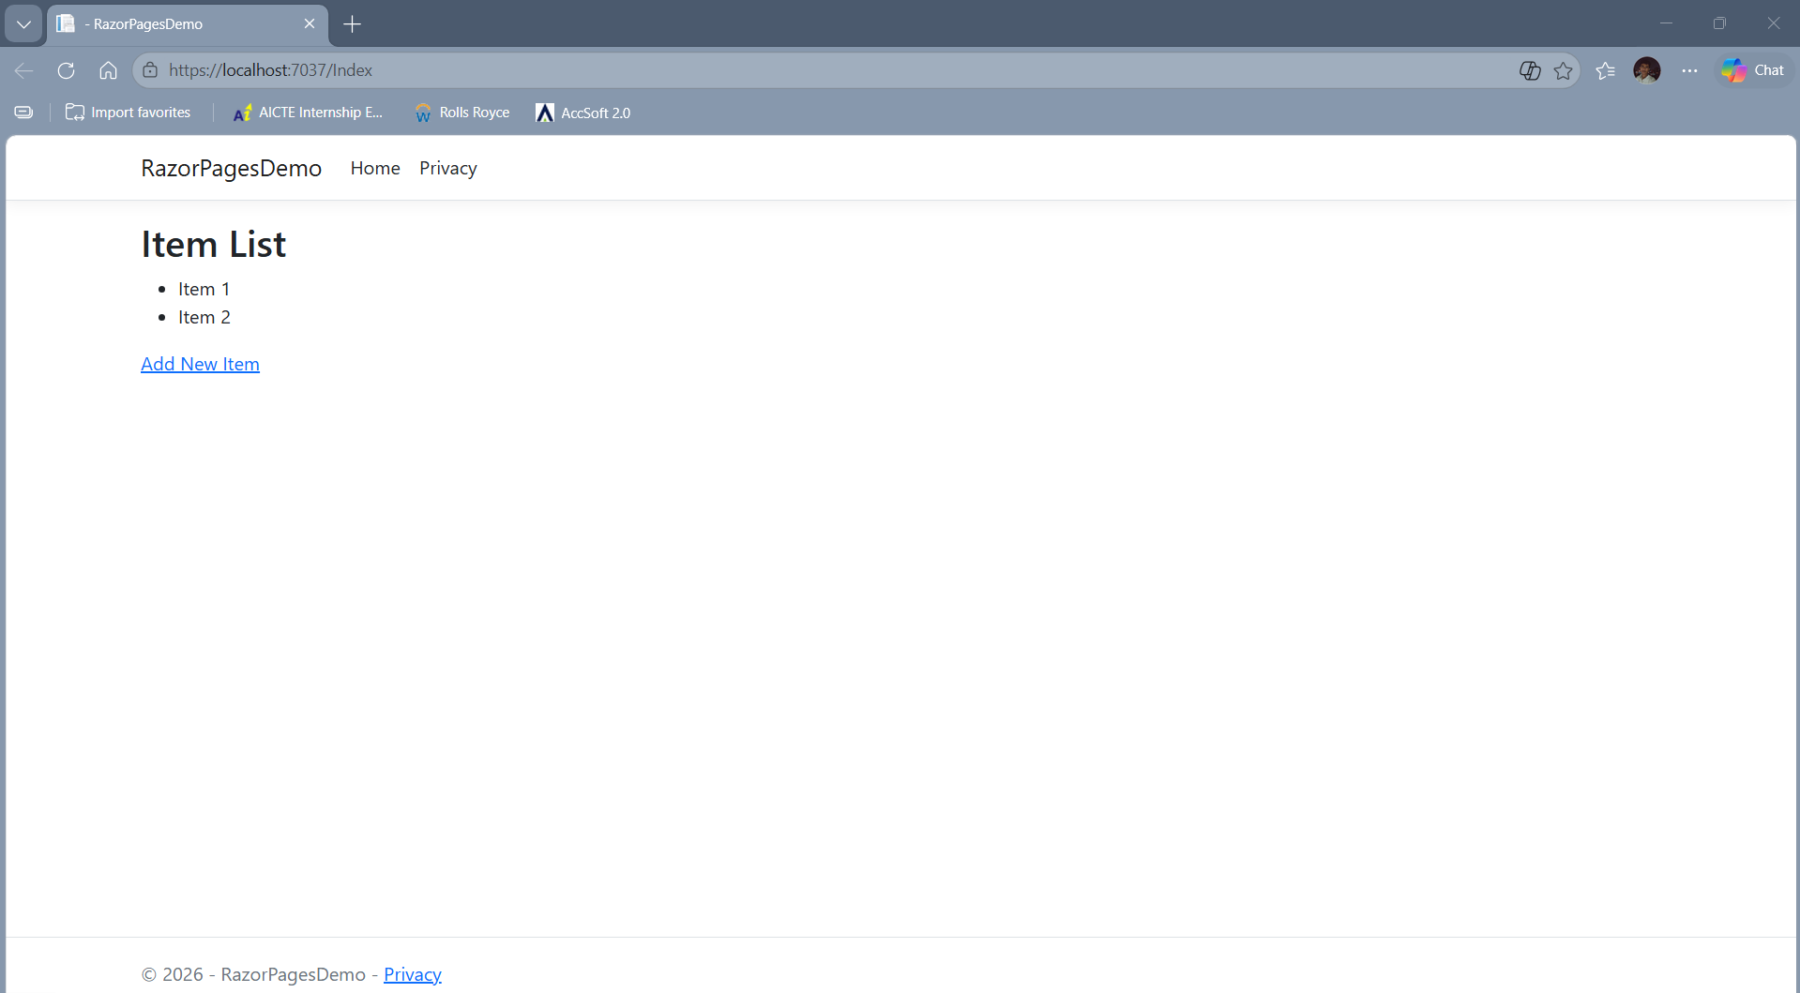

8. Testing
The application was tested to ensure that pages load correctly, navigation works properly, form submission is successful, and dynamic updates are reflected on the Index page.

9. Conclusion
This project demonstrates understanding of Razor Pages architecture, PageModel classes, Razor syntax, and dynamic data handling using ASP.NET Core.

